**Penn Center for Primary Care**

Dr. Rusk Mathew

51 N 39th St #1 Philadelphia, PA 19104

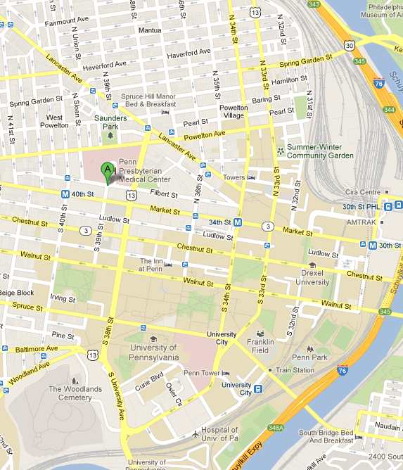

**S**

**N**

**W**

**E**

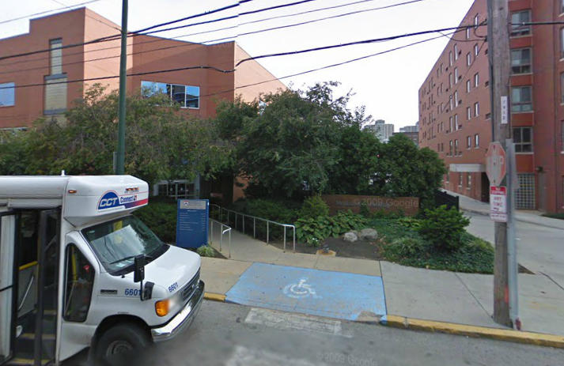

To make **Appointment**

1. Call: **215-662-9990**
2. Press **#1**
3. Wait; ask for **interpreter in your language.**