***OUTBREAK!***

***Tabletop Exercise for Librarians and Refugee Social Workers***

**Save the Date**

**Friday, November 7, 8:30am-3:30pm**

**Parkway Central Library (1901 Vine St), 4th Floor**

**Come learn about resources to help the refugee populations you serve.**

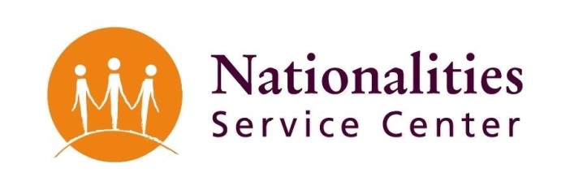**Presenters:**

* **The Free Library of Philadelphia**
* **Philadelphia Refugee Health Collaborative**
* **Philadelphia Department of Public Health**
  + **Tuberculosis Control**
  + **Bedbug Control**
  + **Fire Safety**
  + **Emergency Preparedness**

**Participate in a Pandemic Influenza Tabletop exercise.**

* **Do you know what you and your agency can do to help refugee populations in the event of a flu outbreak?**
* **This is your chance to practice using your resources and working with other agencies!**