**Guidance for TANF Employability Assessment Form and Medical Assessment Form**

**Updated March 2015**



Due to Medicaid Expansion, which went into effect in Pennsylvania on January 1, 2015, the impact of completion for the TANF Employability Assessment form (PA 635) and the Medical Assessment form for non-TANF clients (PA 1663) has changed.

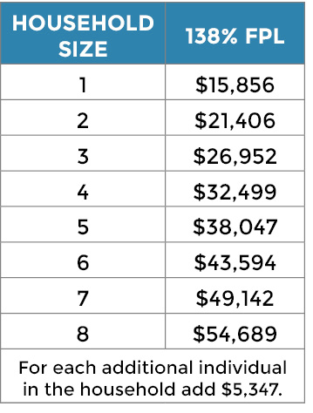

Effective January 1, 2015, all individuals with eligible immigration status who fall under 138% of the federal poverty line automatically qualify for ongoing Medical Assistance/ Medicaid. Clients can apply for continuing coverage directly through the welfare office. No PA 635 or PA 1663 is required.

Therefore the PA 635 and PA 1663 only impact a client’s requirement to enroll in a job readiness/placement program. If a client has a signed PA 635 or PA 1663, they are not eligible to enroll in a job placement or job training program.

In order to ensure that clients are able to access needed job readiness/placement services, please note the following when completing the form PA 635 or PA 1663 or when assisting a client in completing this form.

1. Ask/ Assist the client to complete the front section, “Briefly explain why you cannot work.” This should include the condition(s) why the client believes they are unable to work.
2. Please note the clients near term plans including:
   1. Application for Social Security Disability
   2. Intended participation in a job readiness/ placement program
3. A name and phone number for the client’s case manager to contact with questions.