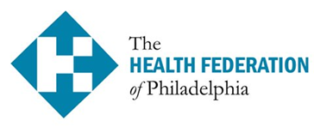 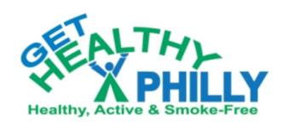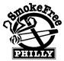

**FREE Training**

**Brief Interventions to Help Smokers**

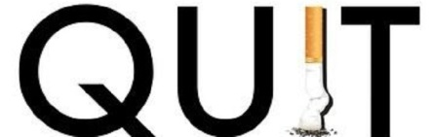

**Date: Friday, September 18, 2015**

**Time: 8:30AM to 12:30 PM**

**Location: Oxford Mills Multi Use Complex**

**100 West Oxford Street, Philadelphia, PA 19122**

Easily accessible by many SEPTA routes – Free parking available

**This training is suitable for Health Educators & Outreach Workers, Medical Assistants *etc.***

**For more information call 215.685.5693 or RSVP to:** [**quitsmokinghelp1@phila.gov**](mailto:helpquit@healthfederation.org)

**by September 10, 2015**

**Participants learn about**

**How Nicotine Addiction Works *Basics of Motivational Interviewing * How to Get and Use Quit Smoking Medications *Local and National Quit Smoking Resources * FAQs on E-Cigs, Hookah, Smokeless Tobacco**

**Training follows US Surgeon General Guidelines for Tobacco Cessation**

**You will receive a Philadelphia Department of Public Health Certificate**

**Training provided by Health Federation of Philadelphia funded by Get Healthy Philly/Smoke Free Philly**