SAVE THE DATE

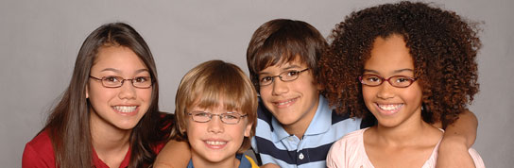
GIVE KIDS SIGHT DAY

Free Eye Care and Free Eyeglasses
Saturday, October 24, 2015
Wills Eye Hospital
9th & Walnut, Philadelphia
No appointment necessary

Especially for children (Birth to 18) who don’t have any health
Insurance or don’t have vision coverage. Children from Bucks,
Chester, Delaware, Montgomery and Philadelphia Counties, are
welcome to join us with a parent or guardian

For more information:
Public Citizens for Children and Youth (PCCY) at
215-563-5848 or email: gksd@pccy.org.
Volunteers are also needed for Give Kids Sight Day. If you can volunteer a few hours of your time, call 215-563-5848 or email gksd@pccy.org. You do not need medical training for many of our volunteer needs.

